
A 10
SET NO : 1

Sreenidhi Institute of Science & Technology
(An Autonomous Institution)
Code No: 101EE01

B. TECH. I – Year II – Semester Examinations, July/Aug, 2011 (Regular)
CIRCUITS NETWORKS - I ( EEE )

Time: 3 Hours Max. Marks : 70

Note : No additional answer sheets will be provided.

Part-A (Objective Type)
Max.Marks:20

Answer all QUESTIONS.

- Define active and passive elements with examples.

- Find the equivalent resistance between the terminals A and B.
2 Ω
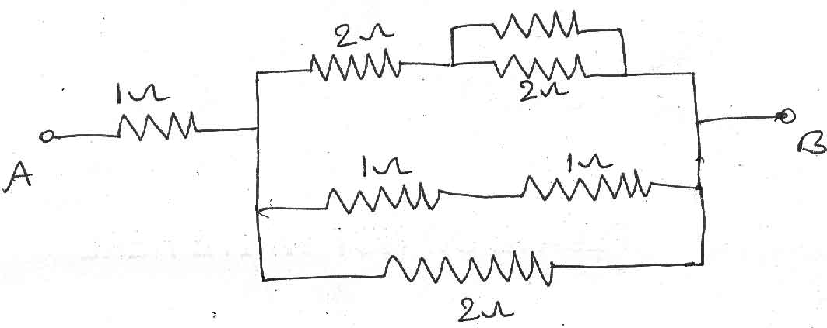

- What is J operator? Explain the significance of it.

- Find the RMS value of the voltage given by

v = 6 + 4 sin ωt + 2 sin(3ωt – π/6) – 3 sin (5ωt+ π/3)

- Find the resonant frequency of a series RLC circuit connected across a variable frequency supply and R = 10 Ω, L= 1mH and C=1000 PF.

- Draw the current locus diagram for a series circuit consisting of variable resistance and fixed inductive reactance.

- Define faraday’s laws of Electro Magnetic Induction.

- Draw a tree and Co-tree for the given below graph.
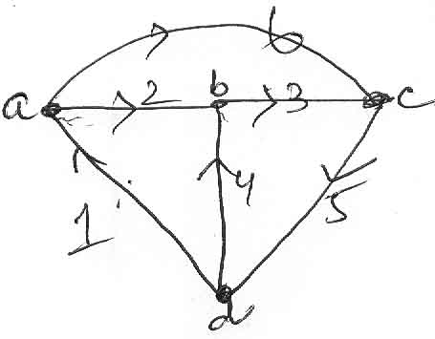

- Find the equivalent inductance for the given coupled circuit.
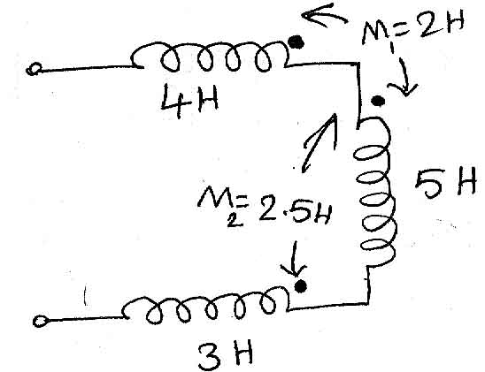

- At what valve of R maximum power will be delivered in the given circuit and also find the value of maximum power.
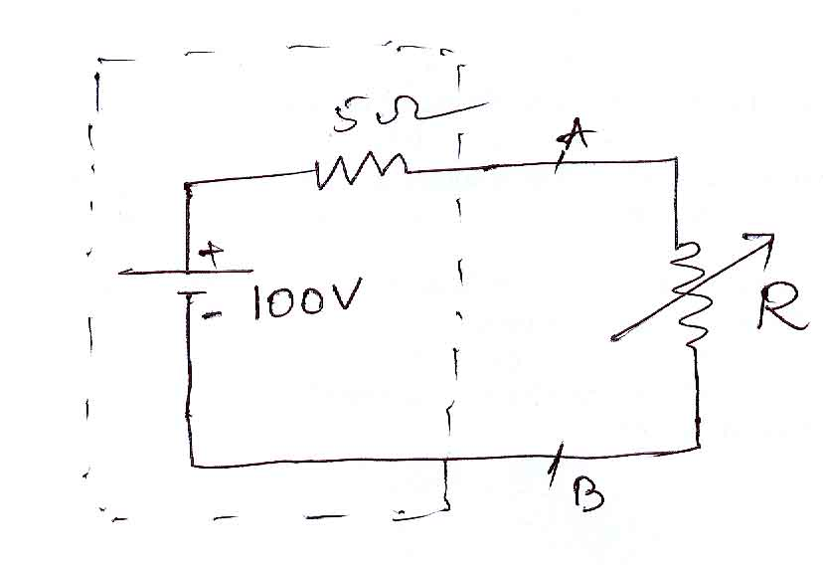

Part – B
Max. Marks: 50

ANSWER ANY FIVE QUESTIONS.
EACH QUESTION CARRIES 10 MARKS.

1. (a) State and explain Kirchoff’s laws. [ 4 ]
(b) A single pure inductance of 3 mH passes a current of the waveform shown in Fig.1(b). Determine and sketch the voltage v(t) and the instantaneous power p(t).
[ 6 ]
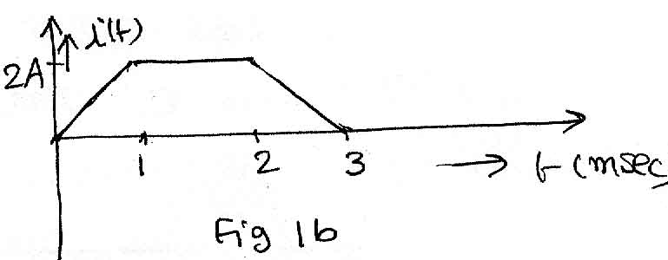

2. (a) Reduce the network to a single voltage source in series with a resistance between the terminals A and B. [ 6 ]
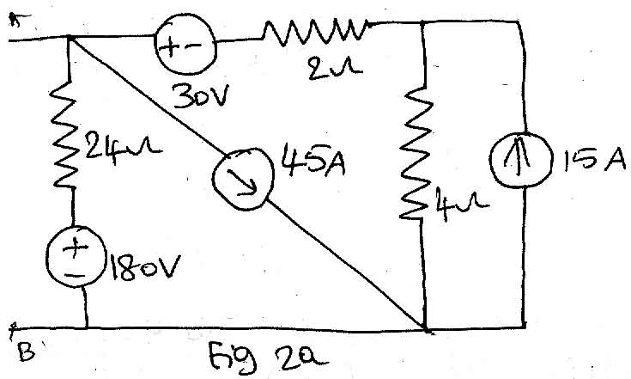

(b) Explain Ideal and practical voltage sources with their V-I characteristics. [ 4 ]

3. (a) Define RMS value, Average value, Form factor and Peak factor. [ 4 ]

(b) Calculate the average and effective values of the waveform shown in
Fig 3 (b). [ 6 ]
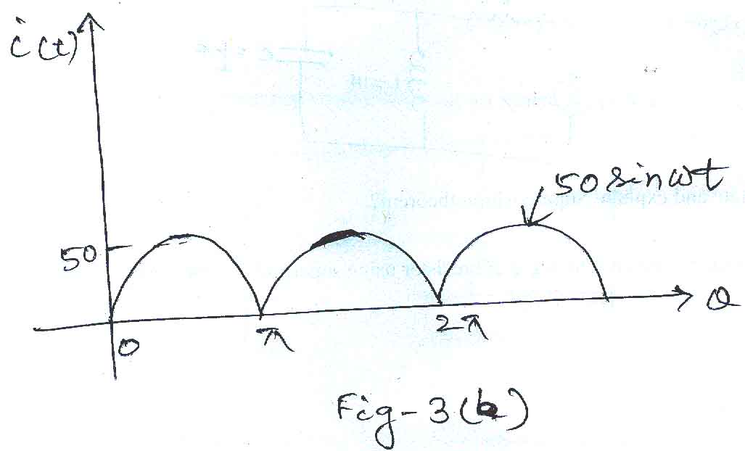

4. (a) An impedance Z₁ = 10 +j10 Ω is connected in parallel with another impedance of resistance 8.5 Ω and a variable capacitance ‘C’ connected in series. Find ‘C’ such that the circuit is in resonance at 5KHz. [ 5 ]
(b) Derive the relationship between Quality factor (Q), Band width (BW) and
Resonant Frequency (F_{r}) of a series RLC circuit under resonance. [ 5 ]

5. (a) What is coefficient of coupling and derive the expression for it between a pair of magnetically coupled coils. [ 4 ]
(b) An iron ring has a mean diameter of 25 cm and an area of across section of 5cm² and is wound with a coil of 1000 turns. Determine the current in the coil to establish a flux density of 0.8 wb/m² in the ring. Take the relative permeability of iron as 500. [ 6 ]

6. (a) Draw the dual of the network for the given network show in Fig. 6(a). [ 5 ]
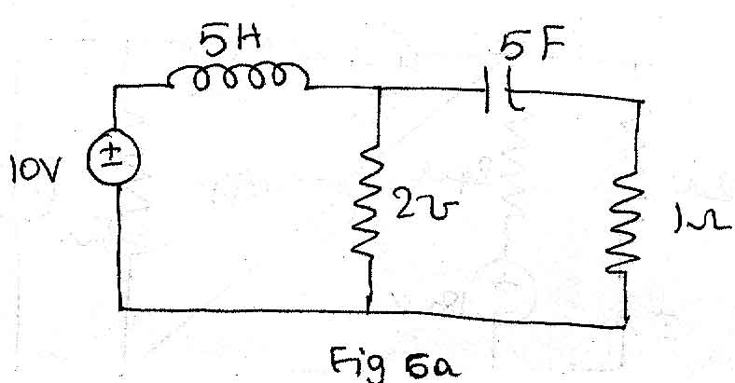
(b) Obtain the fundamental cut-set matrix for the network graph given in Fig. 6(b). [ 5 ]
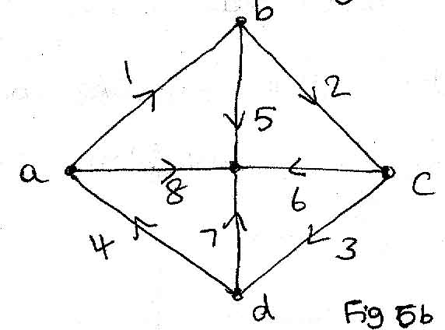

7. (a) For the network shown in Fig. 7(a), determine the current through 2 Ω resistor
using super position theorem. [ 6 ]
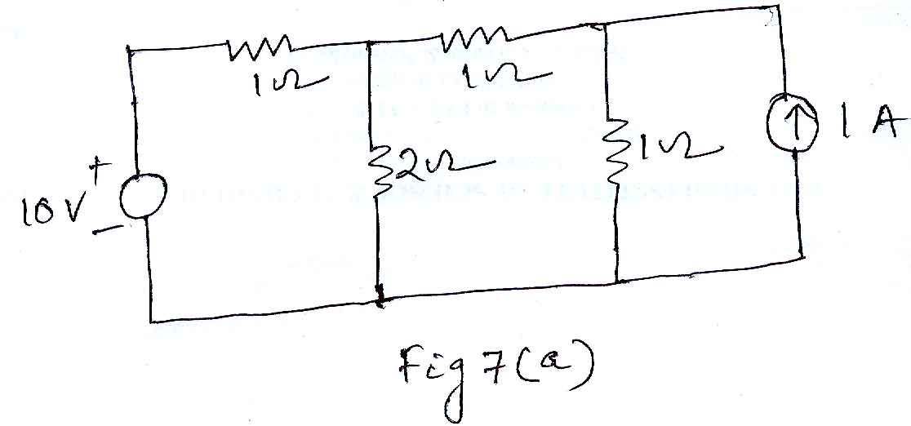
(b) State and explain super position theorem. [ 4 ]

8. (a) Find the current through the branch AB of the network shown in Fig. 8(a) using Thevenin’s Theorem. [ 6 ]
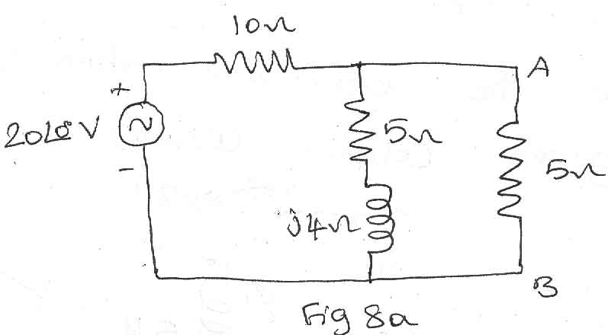
(b) State and explain Maximum power transfer theorem. [ 4 ]

-- 00 -- 00 --

